JAMHURI YA MUUNGANO WA TANZANIA
OFISI YA RAIS, TAWALA ZA MIKOA NA SERIKALI ZA MITAA
HALMASHAURI YA WILAYA YA RUANGWA
SHULE YA SEKONDARI MBEKENYERA
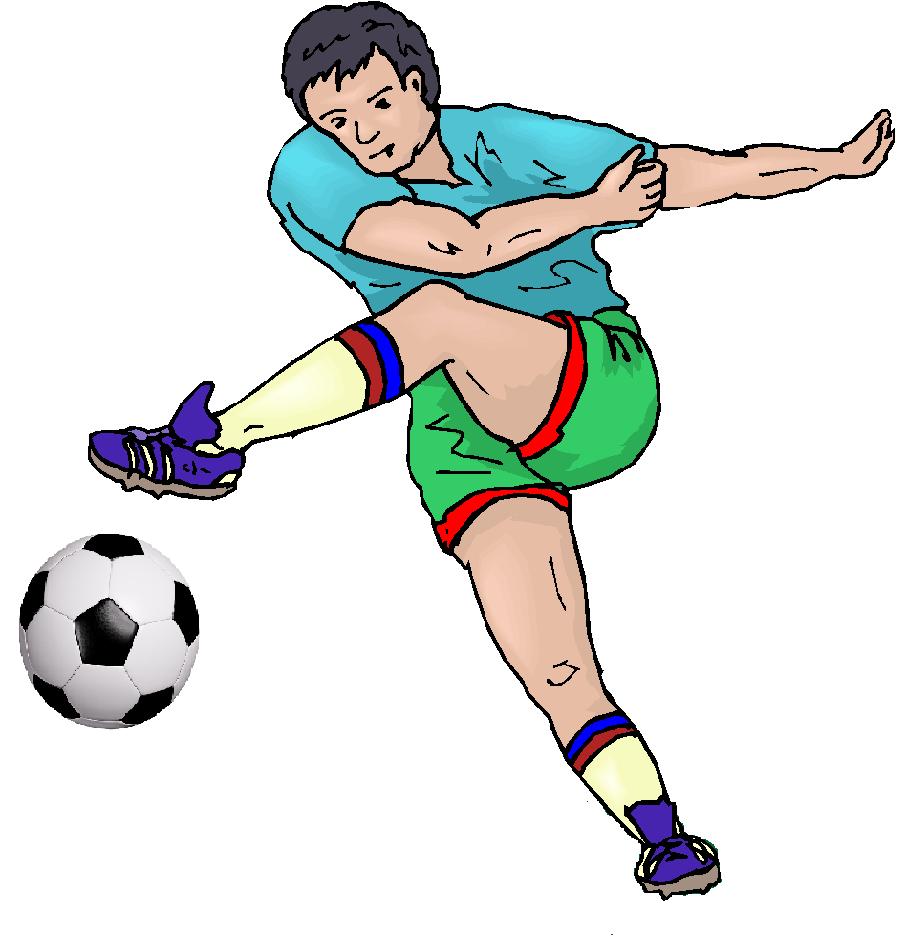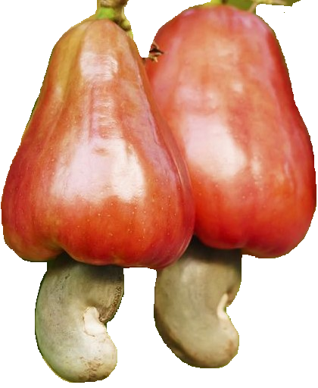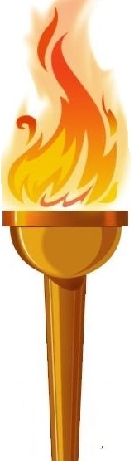

1994

MkuuwaShule
ShuleyaSekondari Mbekenyera
S.L.P. 9, RUANGWA

SIMU
0783500203/0686618393
mbekenyerasecondaryschool@gmail.com

Kumb Na. HWR/MBSS/E.10/VOL.II/…………..............Tarehe ……………..

Jina la Mwanafunzi…………………………………………….…

ShuleyaMsingialiyosoma ....................................................................

YAH: MAAGIZO YA KUJIUNGA KIDATO CHA KWANZA KATIKA SHULE YA SEKONDARI MBEKENYERA MWAKA WA MASOMO2021
Husika nakichwa cha habarihapojuu.
Nachukuanafasihiikukupongezakwakufanyavizurikatikamtihaniwakowadarasa la sabamwaka2020. Ninayofurahakukufahamishakuwaumechaguliwakujiungakidato chaKWANZAkatikashuleyasekondariMBEKENYERAmwaka 2021.
Pamojanabaruahiinimeambatanishafomuzifuatazoambazounatakiwakuzisomakwamakininakuzifanyiakazi.
- FomuyakupimwaafyayaMwanafunzikutokakwenyeHospitaliinayotambulikanaSerikali.
- Fomuyamahitajimuhimuyashule
- Fomuzasheriazashule
- FomuyahabarizaMwanafunzinaMzazi
- Mkatabawakukirikukubaliananasherianakanunizashulepamojanakutekelezamaelekezomengineyatakayotolewakatikavikaohahalivyawazazishuleni
Shuleitafunguliwatarehe11/01/2021hivyokamilishamaandalizimapemailikuwahikuripotishule
NB: UnatakiwakujanaCheti cha kuzaliwanapicha(passport size)
Nakutakiamaandalizimema
KARIBU SANA.
“JUHUDI HULETA MAFANIKIO”

.................................................................
HUSSEIN J. OMARY
MKUU WA SHULE
0783500203/0686618393

MAHITAJI MUHIMU YA SHULE
SarezaShule.
- Surualimbili (2) zakaki(kwawavulana) zenyeurefunaupanawaheshimanazilizoshonwakwaunadhifunasiokwamapambo (ziwena turn up namarindamawilikilaupande).
- Sketimbili (2) zakijani (kwawasichana) zamarindawakawaidazitakazoshonwakwaunadhifu. Fundi atapatikanashuleni.
- Mashatimeupemawili (2) yenyemikonomifupinayenye kola shingoni.
- Viatuvyangozijozi (2) viatuvisiwenaurembowowotenawalavisiwevyakupanda
- Soksiimaranyeupejozimbili (2)
- Nguozamichezo, buktamoja, T-shirt yanjanoisiyonamaandishinaviatuvyamichezo.
- Ajenaswetamoja (1) rangiyakijaniliwe la kufuma.
- T-shirt moja (1) yakijivuyenyenemboyashuleinayopatikanashuleni
MahitajikwaajiliyaTaaluma.
- Counter book 12 siyodaftarindogo(angalau quire 2)
- Kalamuza wino (blue/nyeusi) zakutosha, kalamuyarisasi pencil (HB) narulandefu 1mkebe (oxford) 1
- Failikubwakwaajiliyakutunzakumbukumbuzashule
- Kamusiyakiingereza (dictionary)
- Rim mojakilamuhula
NB:
- Shuleitatoachakula cha mchanakwakuzingatiamakubalianokatikavikaovyawazazi
- GharamazamatibabunaafyayamwanafunzizitashughulikiwanamzazimwenyeweHatahivyounatakiwakulipiaTsh 5,000/= kwaajiliyabimaya CHF iliyoboreshwaili mtoto apatematibabukatikahospitali, vituovyaafyanazahanatibure.
VifaavyaUsafi
Mwanafunzianaporipotishuleajenavifaavifuatavyokwaajiliyausafi:
(a) Fyekeo(b) Fagiolaini (c)Squeezer /dryer (1) (d) dawayachoonilitamoja
(e)Jembelenyempini (f) Panga

THE UNITED REPUBLIC OF TANZANIA
PRESIDENT’S OFFICE REGIONAL ADMINISTRATION AND LOCAL GOVERNMENT
MBEKENYERA SECONDARY SCHOOL,
P.O.BOX 9,
RUANGWA.
DATE..........................................
REF. No………………………………
THE MEDICAL OFFICER.
…………………………………..
……………………………………
……………………………………..

RE: REQUEST FOR MEDICAL EXAMINATION
Mr/Miss……………………………………………………………………….
Please Examine the above named student and give us a regarding his/her suitability for SecondarySchool studies.
Student’s full name ……………………………………………………………….
- Blood....................................................................................................................
- Stool......................................................................................................................
- T.B test...................................................................................................................
- Syphilis test.............................................................................................................
- Urine examination …………………………………………………………….....
- Eye test...................................................................................................................
- Chest......................................................................................................................
- Ear...........................................................................................................................
- Spleen.....................................................................................................................
- Abdomen test..........................................................................................................
- Pregnant test (girls only)………………………………………………….……..

I certify that the above pupil is suitable/unsuitable for studies
If unsuitable please give reasons.......................................................................................................
............................................................................................................................................................
............................................................................................................................................................

Name of MEDICAL Officer...............................................................................
Signature of Medical Officer............................................................................
Date.............................................................................................
Official Stamp...........................................................................

SHULE YA SEKONDARI MBEKENYERA
FOMU YA KUJIANDIKISHA SHULENI NA
HABARI ZA MZAZI NA MWANAFUNZI.

SEHEMU A: HABARI ZA MWANAFUNZI
1. Jinakamili (kamakwenyemtihani)…………………………………………………………
2. Tareheyakuzaliwa …………………………………………………………………………..
3. Kabila ………………………………………………………………………………………..
4. MahalinaWilayaalipozaliwa ……………………………………………………………….
5. ShulealipomalizaDarasa la Saba …………………………………………
6. Kidatoanachokujakuingia …………………………………………………………………….
7. Michezoanayopendelea
NO | JINA LA MCHEZO
I
II
III
IV
V
VI

Kaziyoyoteyauongozialiyowahikufanyakama vile. Kiranja,KiongoziwaKwaya,NgomaMichezon.k
 | UONGOZI | SHULE | MWAKA
i
ii
iii
iii

Nathibitishakwambahabarizilizotolewahapojuunikamilinazaukweli
Tarehe …………………………… saini…………………………………………

HABARI ZA MZAZI

SEHEMU B:
Jina kamili.........................................................................................................................
Kazi...................................................................................................................................
Nyumbani.........................................................................................................................
Kata..................................................................................................................................
Tarafa.................................................................................................................................
(a) AnwaniyaMzazi/Mlezi …………………………………………………………………
(b) Nambayasimu …………………………/…………………………………….
(e) Dini………………………………………………………………
Anuanikamiliyanyumbaniambakomtoto atakuwaanakwendasikuzalikizo………………………………………………………………….....
NinaahidikushirikiananaWalimuilikuhakikishakwambakijanawanguanakuwanatabianzuri,
mchapakazinamwenyebidiiyakusoma.
Mimi ………………………………………………….Mzazi/Mlezininathibitishakuwataarifahiyohapojuunisahihi
Tarehe ………………………………………… saini……………………………………

SHERIA NA KANUNI MUHIMU ZA SHULE.
ShuleinaendeshwakwamujibuwasheriayaElimu Na. 25 yamwaka 1978. AidhaunatakiwakuzingatiamiongozoinayotolewanaWizarayenyedhamanayaElimunchini. Hivyounatakiwakuzingatia mambo yamsingiyafuatayomarabaadayakuripotishuleni.
- HeshimakwaViongozi, Wazazi, Wafanyakaziwote,Wanafunziwenginenajamiikwaujumlanijambo la lazima
- Mahudhuriomazurikatikakilashughulindaninanjeyashulenimuhimu.
- Kuwahikatikakilashughulizashulenanyingineutakazopewa
- Kufahamumipakayashulenakuzingatiakikamilifumaelekezojuuyakuwepondaninanjeyamipakahiyowakatiwotewauanafunzikatikashulehii.
- Kutunzausafiwamwilinamazingirayashule
- Kuvaasareyashulewakatiwote
- Kuzingatiaratibayashulewakatiwote
- Wasichanahawaruhusiwikusukanywele
- ShulehaimfungiMwanafunzikuaminikatikaimaniyakeilakwamudamaalumnasikumaalum
- Hairuhusiwikutokanjeyashulebilaruhusawakatiwamudawamasomo
- Hatakiwikujananguozanyumbanishuleni
- Ajapokuripoti, ajenaMzazi. BilakujanaMzazihatapokelewa
- Ni marufukukuendeshaibadawakatiwamasomo
- Ni marufukumwanafunzikubadilidiniakiwashuleni.
Makosayafuatayoyanawezakusababishaukafukuzwashule.
- Wizi
- UasheratinaUshoga
- Ubakaji.
- Ulevinamatumiziyadawazakulevyakama vile uvutajibangi ,cocaine, mirungi, kubelin.k.
- Kupigana au kupiga
- KuharibukwamakusudimaliyaUmma.
- KudharauBenderayaTaifa
- Kuoa au Kuolewa
- Kupatamimba au kuharibumimbandaninanjeyashule
- Kusababishamimbandani au njeyashule.
- Kugoma, kuchocheanakuongoza au aukuvurugaamaninausalamawashule au watu.
- Kukataaadhabukwamakusudi
- Mwanafunzikuwanasimuyamkononi
- Mwanafunziatakayekutwaanachafuakutazashuleatalazimikakulipandoo (1) yarangipamojanaTshs 10,000/= zaufundiikiwanipamojanakufukuzwashule.

MKATABA WA KUKIRI KUKUBALIANA NA SHERIA NA KANUNI ZA SHULE PAMOJA NA KUTEKELEZA MAELEKEZO MENGINE YATAKAYOTOLEWA KATIKA VIKAO HALALI VYA WAZAZI SHULENI
Mimi …………………………………………….mzazi/mleziwa ..................................................
kaziyanguni...................................................mahalininapoishini ................................................
anuaniyanguni ............................................ nambayasimu..........................................................
Nimesomakwamakinimaelekezonamaagizoyaliyopokwenyefomuhiiyakujiunganashuleyasekondari Mbekenyera. Kwahiariyangunakubalimwananguajiungenashulehii.
Ninahidi:
- Kuwanitamsisitizakuheshimunakufuatataratibu, kanunizotezashule
- Kuwanitashirikikatikavikaombalimbalivyawazazivitakavyoitishwashuleni
- Kuwakutekelezabilaubishiyoteyatakayokubaliwa/kuafikiwakatikavikaovyawazazishuleni
- Kuwanitafuatiliamaendeleoyamwanagushulenakuhakikishaanakujashulekilasikuzamasomo
- Kuwanitakamilishamahitajiyashulekwamwanangukwawakati
- Kuwanitatekelezamaelekezoyatakayotolewanawirazanaidarayaelimukatikangazizote
Endaponitavunjamkatabahuubasinichukuliwehatuazakisheriakwamujibuwa sharia zanchi
SainiyaMzazi/Mlezi ............................................................................................
Sainiya Mwanafunzi........................................................................................................
SainiyaMkuuwashule ……………………………… muhuri........................................

